1. Introduction
The Software Requirement Specification (SRS) document describes the functional and non-functional requirements of the “Solar Energy Product Sales and Service Management System.” This document provides detailed information about the system architecture, modules, interfaces, features, constraints, and performance requirements. The purpose of this document is to guide developers, testers, project managers, and users during the development and maintenance of the application.
The project is designed as a complete web-based platform for managing solar product sales, quotations, customer records, suppliers, installations, online payments, and business operations.

1.1 Purpose
The main purpose of this project is to automate and digitalize solar business management operations. The system provides an online platform where customers can browse solar products, generate quotations, place orders, and make secure payments. Administrators can manage products, suppliers, installations, customers, and reports from a centralized dashboard.
The SRS document defines:
- Functional requirements
- Non-functional requirements
- User interactions
- System interfaces
- Constraints
- Design specifications
- Testing expectations
This document acts as a reference for system development and project implementation.

1.2 Document Conventions
The following conventions are used in this document:
Convention | Meaning
Bold Text | Important terms and headings
Italic Text | References and definitions
Tables | Structured data representation
API | Application Programming Interface
UI | User Interface
DB | Database
Admin | System Administrator

1.3 Intended Audience and Reading Suggestions
This document is intended for:
- Project Developers
- System Analysts
- Database Designers
- Test Engineers
- Project Managers
- MCA Students
- End Users
- System Administrators
Reading Suggestions
Reader | Recommended Sections
Developers | Functional Requirements, APIs, Interfaces
Testers | Testing and Validation Sections
Managers | Scope, Objectives, Feasibility
End Users | Features and User Interfaces

1.4 Product Scope
The “Solar Energy Product Sales and Service Management System” is a full-stack web application developed for managing solar business operations digitally.
The system allows:
- Product browsing
- Cart management
- Online payment
- Quotation generation
- Supplier management
- Customer management
- Installation tracking
- Admin dashboard operations
The platform improves operational efficiency, customer interaction, and data management.

1.5 References
- React.js Documentation
- Node.js Documentation
- Express.js Documentation
- MySQL Documentation
- Razorpay API Documentation
- JWT Authentication Documentation
- REST API Standards
- SPPU MCA Project Guidelines

2. Overall Description
2.1 Product Perspective
The system is a standalone web-based business management application developed using modern full-stack technologies.
The application follows a three-tier architecture:
- Frontend Layer – React.js
- Backend Layer – Node.js + Express.js
- Database Layer – MySQL
The platform integrates:
- Payment Gateway
- REST APIs
- Authentication System
- Database Connectivity

2.2 Product Functions
Major functions of the system include:
Customer Functions
- View solar products
- Add products to cart
- Generate quotations
- Make online payments
- Send enquiries
Admin Functions
- Admin login
- Product management
- Customer management
- Supplier management
- Order management
- Installation management
- Payment monitoring

2.3 User Classes and Characteristics
User Class | Characteristics
Customer | Can browse products and place orders
Admin | Has complete system control
Supplier | Provides solar products and materials
Installer | Handles installation activities

2.4 Operating Environment
Component | Requirement
OS | Windows 10/11
Frontend | React.js with Vite
Backend | Node.js + Express.js
Database | MySQL
Browser | Chrome, Edge
IDE | Visual Studio Code

2.5 Design and Implementation Constraints
- Internet connection required
- MySQL server dependency
- Razorpay integration dependency
- Browser compatibility limitations
- Secure JWT implementation required

2.6 User Documentation
The system provides:
- User-friendly navigation
- Form validations
- Dashboard instructions
- Error notifications
- Payment instructions
Future versions may include:
- User manuals
- Video tutorials
- FAQ modules

2.7 Assumptions and Dependencies
Assumptions
- Users have internet access
- Admin has database access
- Payment gateway services remain active
Dependencies
- Node.js runtime
- MySQL database
- Razorpay APIs
- Axios library
- React.js packages

3. External Interface Requirements
3.1 User Interfaces
The system provides responsive and interactive user interfaces.
Main Interfaces
- Home Page
- Product Page
- Shopping Cart
- Payment Interface
- Admin Dashboard
- Quotation Builder
- Contact Form
UI Features
- Responsive design
- Navigation bar
- Dynamic product cards
- Real-time notifications
- Modal components

3.2 Hardware Interfaces
The system supports:
- Desktop computers
- Laptops
- Mobile devices
- Internet-enabled systems
No specialized hardware is required.

3.3 Software Interfaces
Software | Purpose
React.js | Frontend UI
Node.js | Backend runtime
Express.js | API development
MySQL | Database
Razorpay | Payment processing
Axios | API communication

3.4 Communication Interfaces
The system uses:
- HTTP/HTTPS protocols
- REST APIs
- JSON data exchange
- API-based communication

4. System Features
4.1 User Authentication System
Description
The authentication module secures admin access using JWT authentication.
Features
- Admin login
- Token verification
- Protected routes
- Session management

4.2 Product Management System
Description
Allows administrators to manage solar products.
Features
- Add products
- Update products
- Delete products
- Product listing

4.3 Shopping Cart System
Description
Customers can add products to the shopping cart before checkout.
Features
- Add to cart
- Remove from cart
- Quantity update
- Cart calculation

4.4 Quotation Generation System
Description
Customers can generate quotations for solar products.
Features
- Dynamic quotation calculation
- PDF generation
- Product pricing summary

4.5 Payment Management System
Description
The payment system integrates Razorpay for secure transactions.
Features
- Online payment
- Payment verification
- Transaction tracking
- Invoice generation

4.6 Supplier Management System
Description
Admin can manage supplier details.
Features
- Supplier registration
- Supplier records
- Material management

4.7 Customer Management System
Description
Stores and manages customer information.
Features
- Customer details
- Order history
- Enquiry management

4.8 Installation Management System
Description
Tracks solar installation services.
Features
- Installation scheduling
- Service tracking
- Status updates

4.9 Enquiry Management System
Description
Handles customer enquiries.
Features
- Contact forms
- Query storage
- Admin notifications

5. Other Nonfunctional Requirements
5.1 Performance Requirements
- Fast API response
- Efficient database operations
- Smooth frontend rendering
- Concurrent user handling

5.2 Safety Requirements
- Prevent unauthorized access
- Secure payment processing
- Database backup support
- Error handling mechanisms

5.3 Security Requirements
- JWT authentication
- Password protection
- Input validation
- SQL injection prevention
- Secure API access

5.4 Software Quality Attributes
Attribute | Description
Reliability | Stable system performance
Scalability | Supports future expansion
Maintainability | Easy code management
Availability | Continuous system access
Usability | User-friendly interface

5.5 Business Rules
- Admin approval required for management operations
- Secure payment verification mandatory
- Products must contain valid pricing
- Orders require customer information
- Installation records must be maintained

6. Other Requirements
Additional requirements include:
- Responsive UI support
- Database connectivity
- API integration
- Error handling
- Report generation
- Future AI enhancements
Possible future AI features:
- AI product recommendation
- Smart quotation prediction
- Chatbot support
- Predictive analytics

Appendix A: Glossary
Term | Meaning
API | Application Programming Interface
JWT | JSON Web Token
DBMS | Database Management System
UI | User Interface
REST API | Web communication architecture
Razorpay | Online payment gateway

Appendix B: Analysis Models
Entity Relationship (ER) Diagram
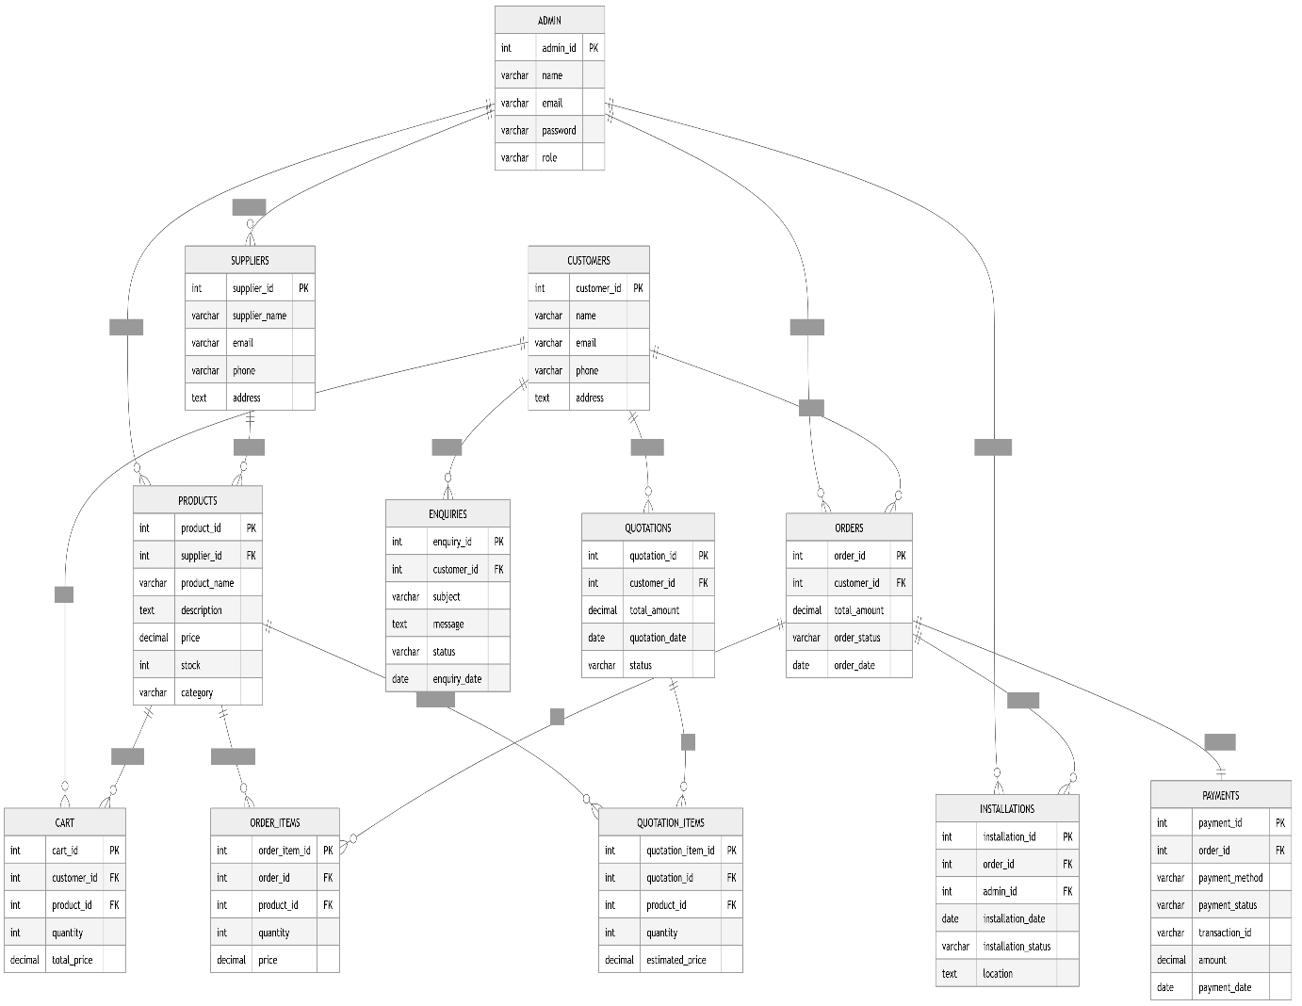

Class Diagram

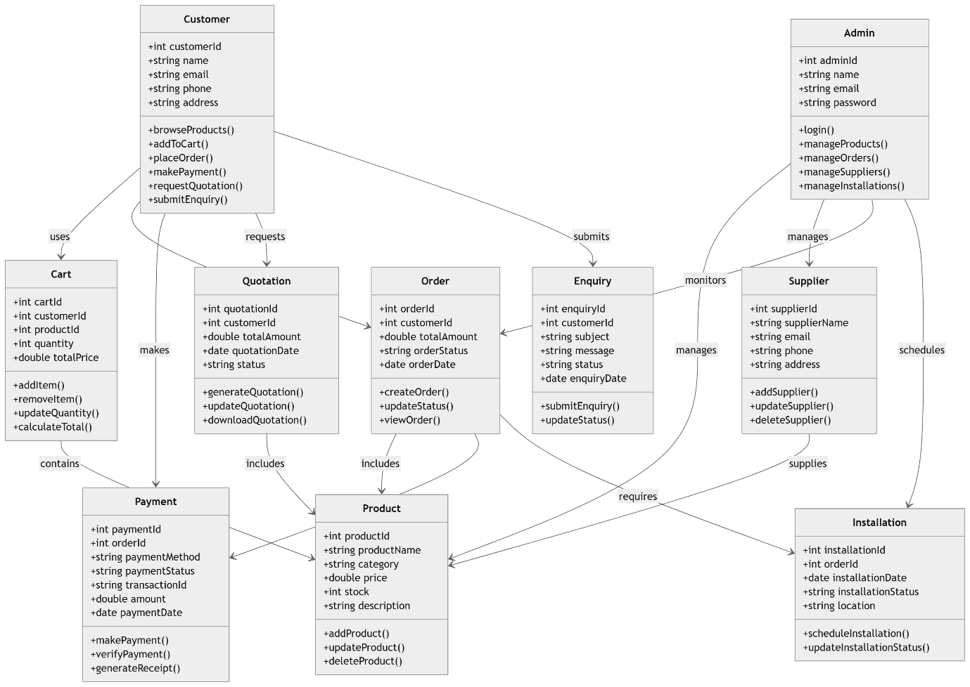

Context Level Diagram
Level 0 DFD

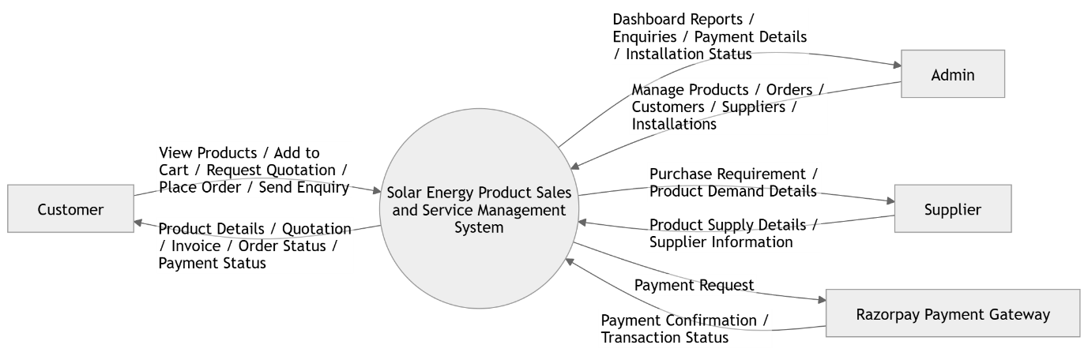

Data Flow Diagram (Level 1)
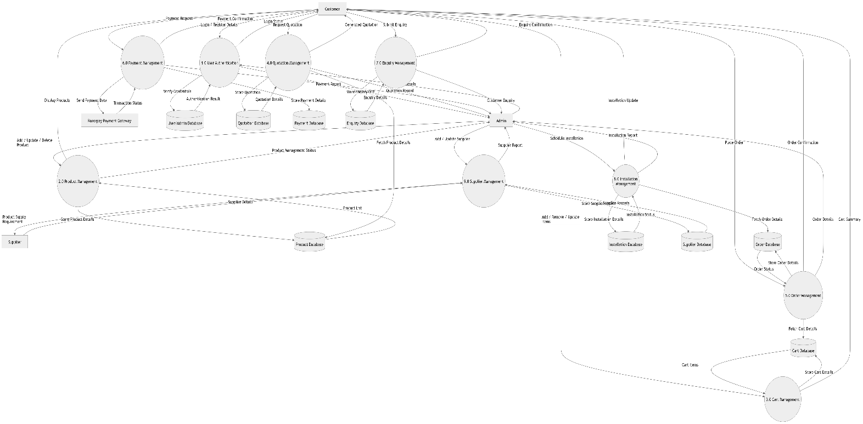

Use Case Diagram
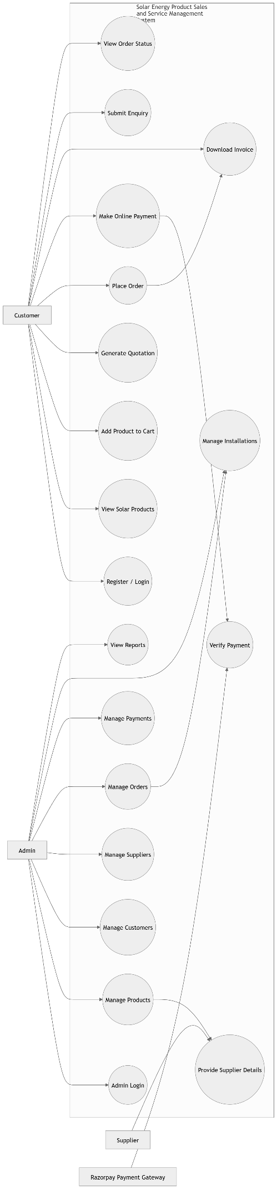
Activity Diagram
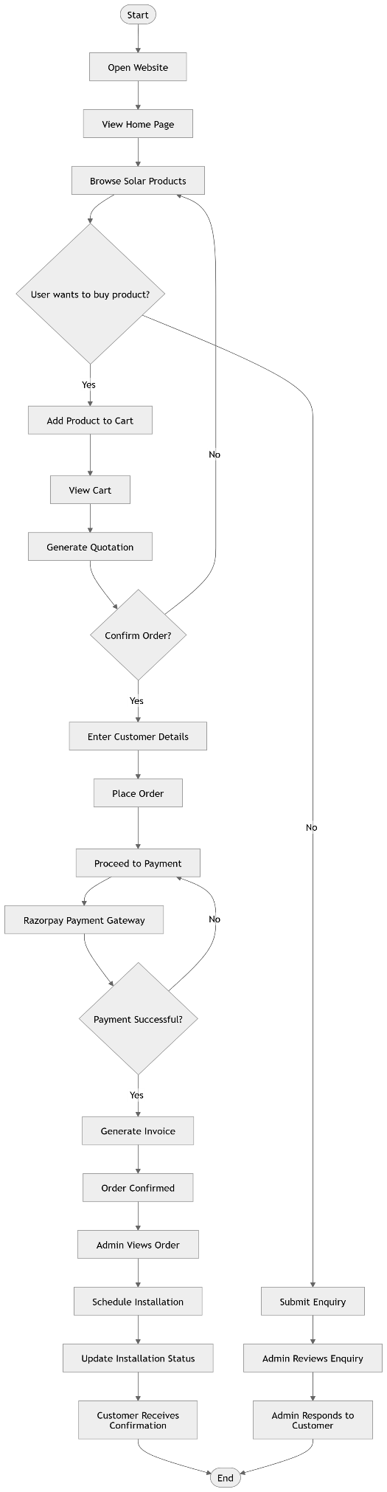
Sequence diagram
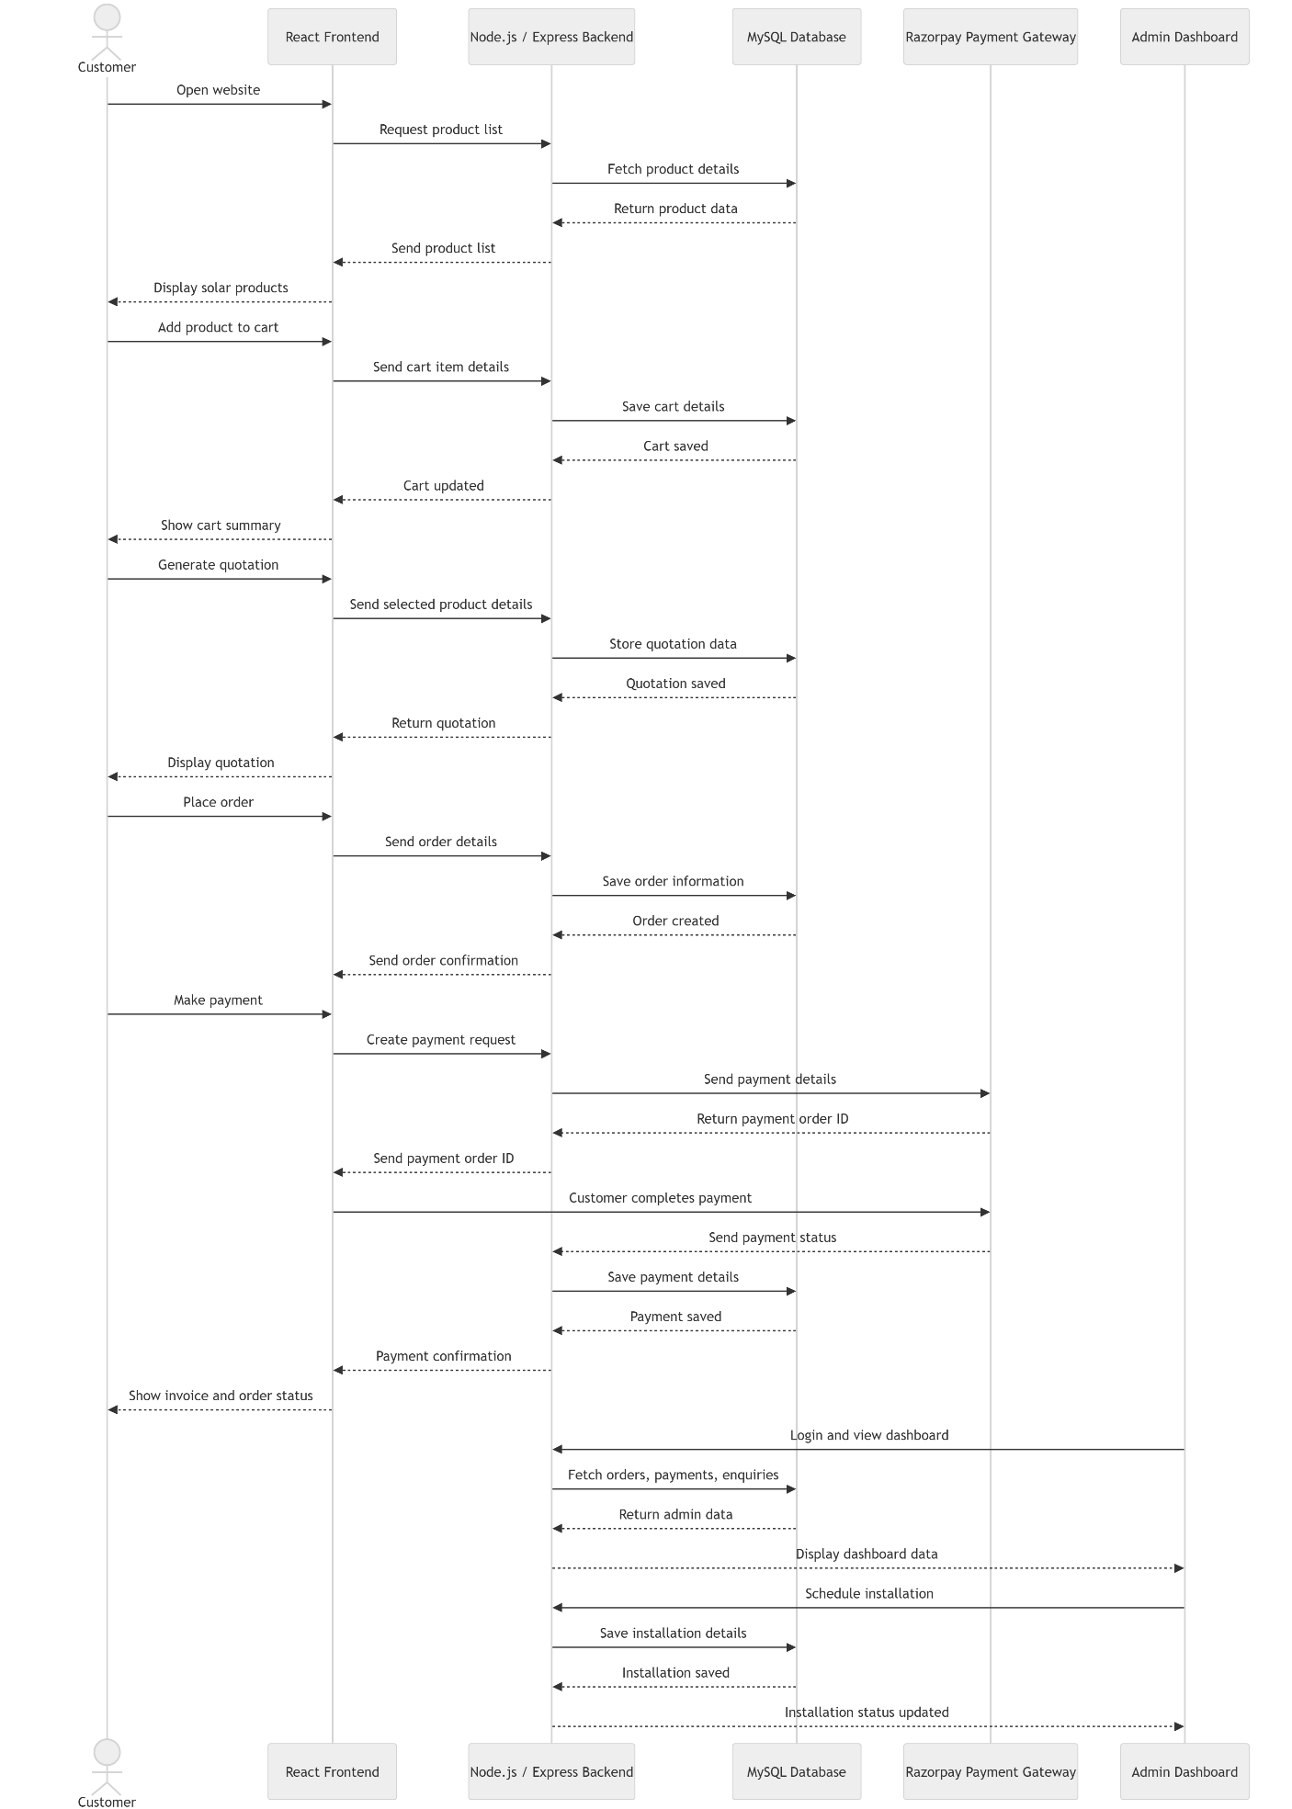

State Diagram
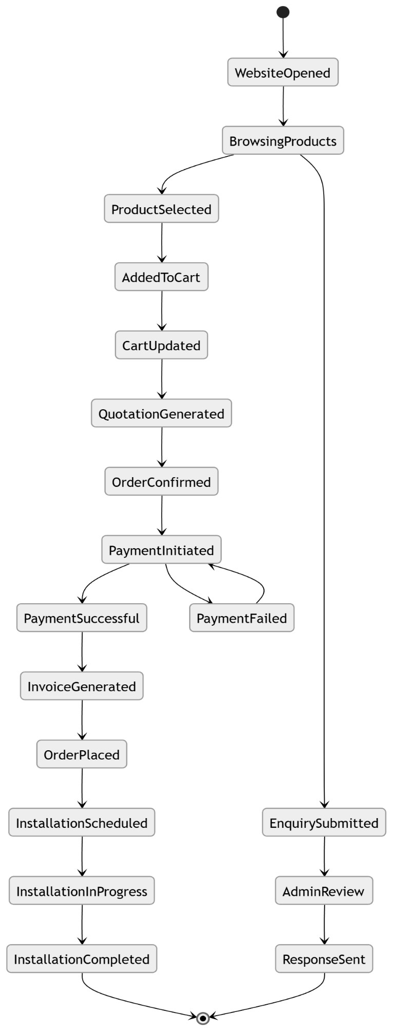

Component Diagram

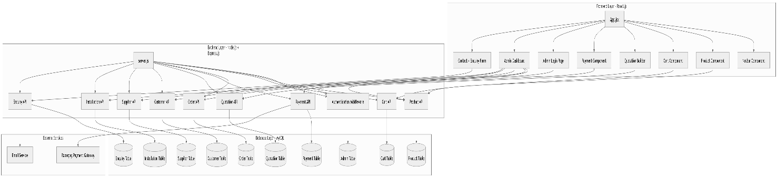

Deployment Diagram
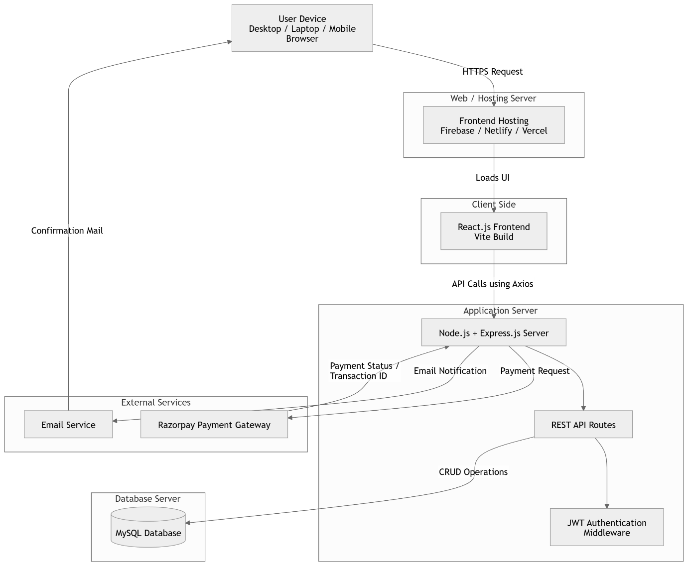

ER Model
Entities:
- Users
- Products
- Orders
- Payments
- Suppliers
- Installations
Component Model
Frontend:
- React Components
Backend:
- Express APIs
Database:
- MySQL

